Pentagonal Rotunda
# Source: AI Source: Provided by: [Data Path: Persons Table -> ID Column: 1, Name_En Column: Motasem Essam] -> From: [ChatGPT] on [7/25/2026]
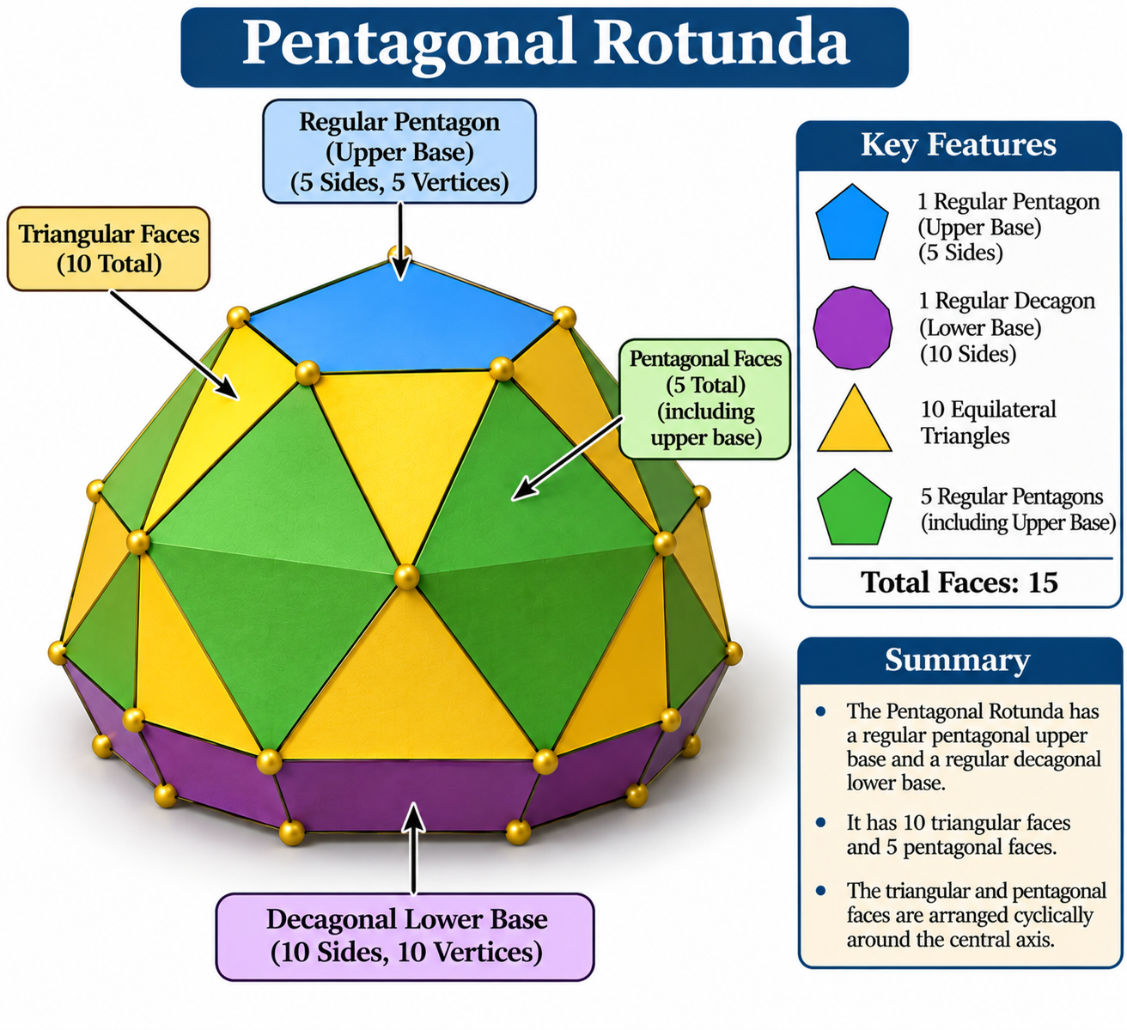

Definition
# Source: AI Source: Provided by: [Data Path: Persons Table -> ID Column: 1, Name_En Column: Motasem Essam] -> From: [ChatGPT] on [7/25/2026]
A Pentagonal Rotunda, also known as Pero, is a convex polyhedron characterized by a regular pentagonal upper base, a regular decagonal lower base, and a cyclic arrangement of triangular and pentagonal lateral faces.
It is the sixth Johnson solid (J6) and the only classical rotunda that has all regular polygonal faces with equal edge lengths.
The Pentagonal Rotunda can also be obtained by dividing an Icosidodecahedron into two halves along one of its decagonal circuits of edges. <Cite refs={["turn495132search0","turn495132search2","turn495132search3"]}/>
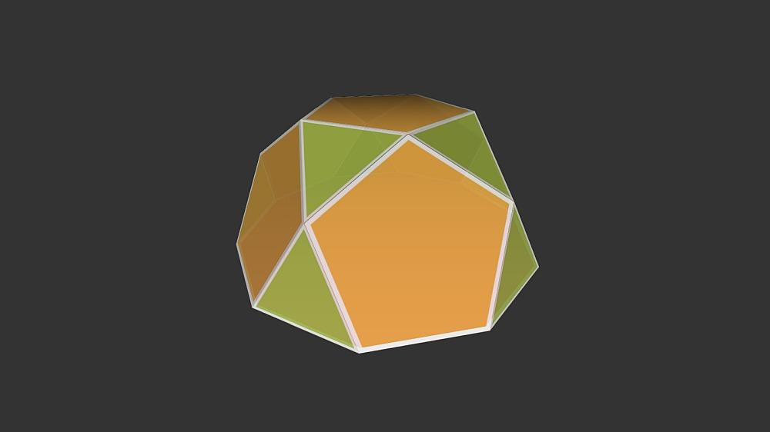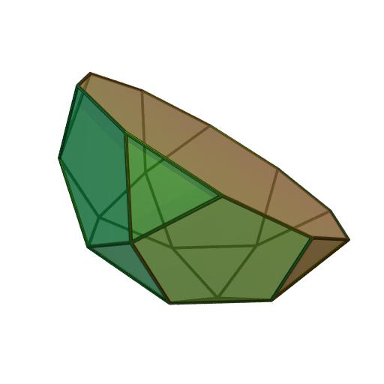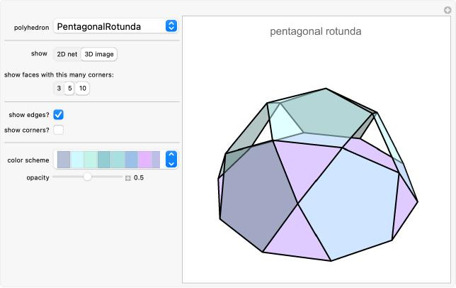

Geometric Structure
# Source: AI Source: Provided by: [Data Path: Persons Table -> ID Column: 1, Name_En Column: Motasem Essam] -> From: [ChatGPT] on [7/25/2026]
The Pentagonal Rotunda consists of:
- Upper Base: A regular pentagon with five sides and five vertices.
- Lower Base: A regular decagon with ten sides and ten vertices.
- Triangular Faces: Ten equilateral triangular lateral faces.
- Pentagonal Faces: Five pentagonal lateral faces, together with the upper pentagonal base.
- Cyclic Arrangement: The triangular and pentagonal lateral faces are arranged around the central axis.
<Cite refs={["turn495132search0","turn495132search1","turn495132search3"]}/>

Face Composition
# Source: AI Source: Provided by: [Data Path: Persons Table -> ID Column: 1, Name_En Column: Motasem Essam] -> From: [ChatGPT] on [7/25/2026]
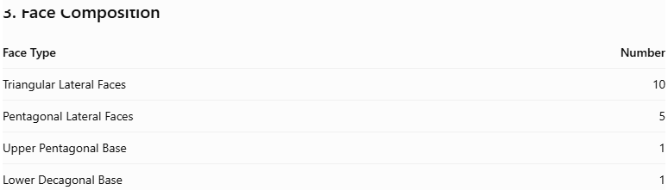
Face Type | Number
Triangular Lateral Faces | 10
Pentagonal Lateral Faces | 5
Upper Pentagonal Base | 1
Lower Decagonal Base | 1
Total Faces | 17
The complete structure contains 10 equilateral triangles, 6 regular pentagons (including the upper base), and 1 regular decagon. <Cite refs={["turn495132search0","turn495132search1","turn495132search4"]}/>

Mathematical Properties
# Source: AI Source: Provided by: [Data Path: Persons Table -> ID Column: 1, Name_En Column: Motasem Essam] -> From: [ChatGPT] on [7/25/2026]

Property | Value
Total Faces (F) | 17
Total Edges (E) | 35
Total Vertices (V) | 20
Upper Base | Regular Pentagon
Lower Base | Regular Decagon
Johnson Solid Number | J6
Symmetry Group | $$C_{5v}$$
Rotational Symmetry | Order 5
Full Symmetry Order | 10
Geometric Type | Convex Polyhedron
<Cite refs={["turn495132search1","turn495132search2","turn495132search15"]}/>
General Rotunda Formulas:
For an $n$-gonal Rotunda:
$$F=3n+2, E=7n, V=4n$$
For the Pentagonal Rotunda, $n=5$:
$$F=17, E=35, V=20$$
Euler's Polyhedron Formula:
$$V-E+F=2$$
$$20-35+17=2$$

Geometric Characteristics
# Source: AI Source: Provided by: [Data Path: Persons Table -> ID Column: 1, Name_En Column: Motasem Essam] -> From: [ChatGPT] on [7/25/2026]
- Pentagonal Upper Base: Its upper base is a regular pentagon.
- Decagonal Lower Base: Its lower base is a regular decagon.
- Triangular Lateral Faces: Ten equilateral triangles form part of the lateral surface.
- Pentagonal Lateral Faces: Five regular pentagons connect the upper and lower portions.
- Fivefold Rotational Symmetry: Its structure repeats after a rotation of ${72}^{∘}$.
- Icosidodecahedron Relationship: It can be constructed as one half of an icosidodecahedron.
- Johnson Solid: It is classified as J6 and has all regular polygonal faces with equal edge lengths.

Construction of Pentagonal Rotunda

Geometric Instruments Used
# Source: AI Source: Provided by: [Data Path: Persons Table -> ID Column: 1, Name_En Column: Motasem Essam] -> From: [ChatGPT] on [7/25/2026]
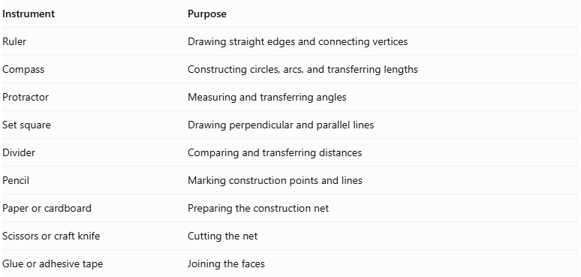
Instrument | Purpose
Ruler | Drawing straight edges and connecting vertices
Compass | Constructing circles, arcs, and transferring lengths
Protractor | Measuring and transferring angles
Set square | Drawing perpendicular and parallel lines
Divider | Comparing and transferring distances
Pencil | Marking construction points and lines
Paper or cardboard | Preparing the construction net
Scissors or craft knife | Cutting the net
Glue or adhesive tape | Joining the faces

Instrument-Based Construction Procedures
# Source: AI Source: Provided by: [Data Path: Persons Table -> ID Column: 1, Name_En Column: Motasem Essam] -> From: [ChatGPT] on [7/25/2026]
No coordinate-based construction
The construction uses geometric instruments, compass-and-straightedge polygon construction, measured angles, and geometric relationships. It does not use coordinate axes, coordinate points, or coordinate equations.

Construct the Upper Regular Pentagon
# Source: AI Source: Provided by: [Data Path: Persons Table -> ID Column: 1, Name_En Column: Motasem Essam] -> From: [ChatGPT] on [7/25/2026]
- Draw a circle using a compass.
- Construct a regular pentagon inscribed in the circle using a compass and ruler.
- Mark five equally spaced vertices on the circumference.
- Join consecutive vertices using a ruler.
- Verify that all five sides are equal.
- Label the vertices $A,B,C,D,E$.

Construct the Lower Regular Decagon
# Source: AI Source: Provided by: [Data Path: Persons Table -> ID Column: 1, Name_En Column: Motasem Essam] -> From: [ChatGPT] on [7/25/2026]
- Draw a second circle using a compass.
- Construct two perpendicular diameters through its center.
- Bisect the right angles to create eight equally spaced points.
- Bisect the appropriate central angles further to obtain ten equally spaced points around the circumference.
- Join consecutive points using a ruler.
- Verify that all ten sides are equal.
- Label the vertices $P_{1},P_{2},…,P_{10}$.
A regular decagon can be constructed exactly with a compass and straightedge.

Construct the Ten Equilateral Triangular Faces
# Source: AI Source: Provided by: [Data Path: Persons Table -> ID Column: 1, Name_En Column: Motasem Essam] -> From: [ChatGPT] on [7/25/2026]
- Set the compass to the common edge length $a$.
- Draw an equilateral triangle using the compass and ruler.
- Repeat the construction to produce ten equilateral triangles.
- Label the triangles according to their intended positions around the rotunda.
- Verify that each triangle has three equal sides and three ${60}^{°}$ interior angles.

Construct the Five Regular Pentagonal Lateral Faces
# Source: AI Source: Provided by: [Data Path: Persons Table -> ID Column: 1, Name_En Column: Motasem Essam] -> From: [ChatGPT] on [7/25/2026]
- Construct five regular pentagons using a compass and ruler.
- Use the same side length $a$ as the triangular faces.
- Verify that each pentagon has five equal sides and five equal interior angles of ${108}^{°}$.
- Label the pentagons according to their intended positions in the lateral arrangement.

Arrange the Lateral Faces
# Source: AI Source: Provided by: [Data Path: Persons Table -> ID Column: 1, Name_En Column: Motasem Essam] -> From: [ChatGPT] on [7/25/2026]
- Position the regular pentagonal upper base and regular decagonal lower base parallel to each other.
- Arrange the ten triangular faces and five pentagonal faces in the prescribed Johnson-solid adjacency pattern.
- Match every shared edge so that its length is exactly $a$.
- Ensure that each lateral pentagon is connected to the appropriate neighboring triangles.
- Check that the arrangement closes around the entire solid without gaps or overlapping faces.

Assemble the Solid
# Source: AI Source: Provided by: [Data Path: Persons Table -> ID Column: 1, Name_En Column: Motasem Essam] -> From: [ChatGPT] on [7/25/2026]
- Prepare a verified net containing the 17 faces and their correct edge connections.
- Add small joining tabs if using paper or cardboard.
- Cut out the complete net.
- Fold along the required edges.
- Join the matching lateral faces.
- Attach the pentagonal upper base and decagonal lower base.
- Inspect the finished model to ensure that all edges are joined and the solid is closed.
Construction accuracy: The Pentagonal Rotunda is a specific, well-defined Johnson solid. Its face arrangement must follow the correct J₆ adjacency pattern. Merely drawing the correct number of regular polygons and joining them arbitrarily will not produce the Pentagonal Rotunda.

Key Points
# Source: AI Source: Provided by: [Data Path: Persons Table -> ID Column: 1, Name_En Column: Motasem Essam] -> From: [ChatGPT] on [7/25/2026]
- Alternative Name: Pero.
- Upper Base: Regular Pentagon.
- Lower Base: Regular Decagon.
- Triangular Lateral Faces: 10.
- Pentagonal Lateral Faces: 5.
- Total Faces: 17.
- Total Edges: 35.
- Total Vertices: 20.
- Rotational Symmetry: Order 5.
- Johnson Solid Number: J6.
- Classification: Convex Johnson Solid.

Main Classification
# Source: AI Source: Provided by: [Data Path: Persons Table -> ID Column: 1, Name_En Column: Motasem Essam] -> From: [ChatGPT] on [7/25/2026]
Solid Geometry
└── Types of Solids
└── Rotunda
└── Types of Rotundas
└── Pentagonal Rotunda

Conclusion
# Source: AI Source: Provided by: [Data Path: Persons Table -> ID Column: 1, Name_En Column: Motasem Essam] -> From: [ChatGPT] on [7/25/2026]
The Pentagonal Rotunda is a convex polyhedron characterized by its regular pentagonal upper base, regular decagonal lower base, and lateral arrangement of ten triangular and five pentagonal faces. It has 17 faces, 35 edges, and 20 vertices, with fivefold rotational symmetry.
Important distinction: The Pentagonal Rotunda is the classical regular-faced Rotunda and Johnson solid J6. It is also geometrically related to the Icosidodecahedron, of which it forms one half. <Cite refs={["turn495132search0","turn495132search2","turn495132search3"]}/>

